1. **Attempt any 5 of the following**

a) Differentiate between Batch Operating System and Time shared Operating System.

(any two points)

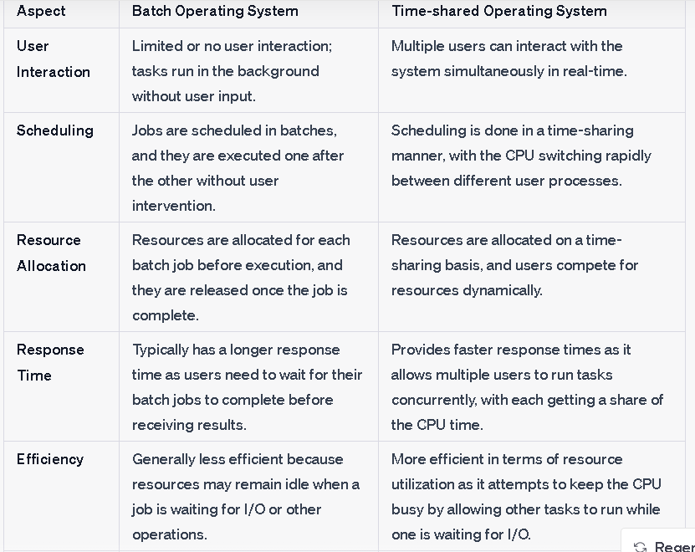

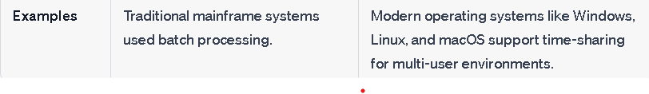

**b) State any four services of Operating System**

**1.**User Interface: All operating systems have a user interface that

allows users to communicate with the system. Three types of user

interfaces are available:

**a. Command line interface (CLI)**

**b. Batch interface**

**c. Graphical user interface (GUI)**

**2. Program execution**: The operating system provides an environment

where the user can conveniently run programs. It also performs other

important tasks like allocation and deallocation of memory, CPU

scheduling etc. It also provides service to end process execution either

normally or abnormally by indicating error.

**3. I/O operations:** When a program is running, it may require

input/output resources such as a file or devices such as printer. So the

operating system provides a service to do I/O.

**4.File system manipulation:** Programs may need to read and write data

from and to the files and directories. Operating system manages the

secondary storage. Operating system makes it easier for user programs

to accomplish their task such as opening a file, saving a file and deleting

a file from the storage disk.

**5.Communication**: In the system, one process may need to exchange

information with another process. Communication can be implemented

via shared memory or through message passing, in which packets of

information are moved between processes by the operating system.

**6.Error detection**: Operating systems detects CPU and memory

hardware such as a memory error or power failure, a connection failure

on a network or lack of paper in the printer etc.

**7.Resource allocation:** Operating system manages resource allocation

to the processes. These resources are CPU, main memory, file storage

and I/O devices.

**8.Accounting:** Operating system keeps track of usages of various

computer resources allocated to users**.**

**9.Protection & security:** When several separate processes execute

concurrently, one process should not interfere with the other processes

or operating system itself. Protection provides controlled access to

system resources. Security is provided by user authentication such as

password for accessing information

**c)Define: Process, Program**

**1.PROCESS**

A process is a program in execution. Process is also called as job, task or unit of work. The

execution of a process must progress in a sequential fashion. Process is an active entity.

**2.PROGRAM**

A Program is a group of ordered operation to achieve a programming goal .

It only needs memory for storage. A program is a passive or static entity.

**d) State two features of preemptive scheduling**

Preemptive scheduling is a type of scheduling used in operating systems where the operating system can forcibly interrupt a running process and allocate the CPU to another process. Two key features of preemptive scheduling are:

**Priority-Based Preemption**: Preemptive scheduling often uses priorities assigned to processes. Higher priority processes can preempt lower priority processes, ensuring that critical or high-priority tasks are executed promptly. The operating system can interrupt a lower priority task if a higher priority task becomes ready to execute.

**Time Quanta (Time Slice):** Preemptive scheduling often employs time quanta or time slices, which are small, fixed time intervals. Each process is allocated a time slice during which it can execute. When the time slice expires, the operating system interrupts the process, even if it hasn't completed its execution, and switches to another process. This ensures fairness and prevents any single process from monopolizing the CPU for extended periods.

**Defione following terms**

**i) Page fault**

**ii) Segmentation**

**Page fault**: When the process executes and accessed the pages that are present into memory, execution proceeds normally. But if the process tries to access a page which is marked invalid, then it causes a page fault trap. This trap occurs because operating system has failed to bring the desired page into memory. The main functions of paging are performed when a program tries to access pages that do not currently reside in the RAM. This situation is known as page fault. The OS must take control and handle the page fault.

**Segmentation**

Segmentation is a memory management technique used in computer systems to divide a computer's primary memory (RAM) into segments or blocks of varying sizes. Each segment corresponds to a logical unit or address space, such as a process, program, or data structure. Segmentation provides a way to organize and protect memory, allowing for more efficient memory allocation and management. Each segment can have its own permissions and attributes, and the operating system keeps track of the starting address and length of each segment. This approach enables flexibility in memory allocation, facilitates sharing of memory between processes, and simplifies memory protection by isolating segments from one another.

**f) Write syntax of ps command and explain its use with the help of suitable example**.

ps command: It is used to display the characteristics of a process. This

command when execute without options, it lists the processes associated

with a user at a particular terminal.

Syntax: $ ps [options]

Example: $ ps

output:

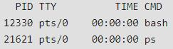

Each line in the output shows PID, the terminal with which the process

is associated, the cumulative processor time that has been consumed

since the process has been started and the process name.

Options:

-f : It is used to display full listing of attributes of a process. It includes

UID (user ID),PPID(Parent ID),C(amount of CPU time consumed by

the process) and STIME(chronological time that has elapsed since the

process started).

Example: $ ps -f

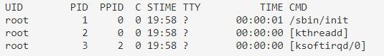

-u: Shows the activities of any specified user at any time.

Example: $ ps -u abc

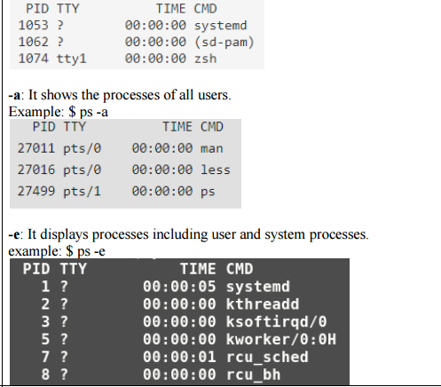

**g)List any four file attributes.**

File attributes:

• Name: The symbolic file name is the only information kept in human readable form.

• Identifier: File system gives a unique tag or number that identifies file within file

system and which is used to refer files internally.

• Type: This information is needed for those systems that support different types.

• Location: This information is a pointer to a device and to the location of the file on

that device.

• Size: The current size of the file (in bytes, words or blocks) and possibly the maximum

allowed size are included in this attribute.

• Protection: Access control information determines that who can do reading, writing,

executing and so on.

• Time, Date and User Identification: This information may be kept for creation, Last

modification and last use. These data can be useful for protection, security and usage

monitoring.

**Q.2) Attempt any THREE of the following. 12 Marks**

**a) Explain dual modes of operations of an Operating system.The dual modes of operation in an operating system refer to the presence of two distinct privilege levels or modes that help in ensuring the proper functioning and security of the system. These modes are commonly known as user mode and kernel mode. Here's an explanation of the dual modes of operation:**

**1. **User Mode** (or User Space):**

- In user mode, the CPU operates with restricted privileges and limitations.

- User mode is the mode in which application programs and user processes run.

- Processes in user mode do not have direct access to the underlying hardware or sensitive system resources.

- They are confined to their allocated memory space and have limited capabilities to prevent them from interfering with critical system operations.

- Any attempt to perform privileged operations or access restricted resources in user mode will result in a trap or exception, and control is transferred to the kernel mode for handling.

**2. **Kernel Mode** (or Supervisor Mode, System Mode):**

- Kernel mode is a privileged mode of operation with unrestricted access to system resources and hardware.

- In this mode, the operating system's kernel, which includes critical system processes and device drivers, executes.

- The kernel has direct access to hardware, system memory, and sensitive instructions.

- It is responsible for managing all system functions, such as process scheduling, memory management, I/O operations, and hardware control.

- The kernel can execute privileged instructions and manage hardware interrupts without restrictions.

**b)Describe essential activities done by an Operating System for protection and sharing.**

An operating system performs essential activities for both protection and sharing in a computer system. These activities are crucial to ensure the security and controlled access to system resources while facilitating resource sharing among multiple processes. Here are four key activities related to protection and sharing:

**1. **Process Isolation**:**

**- Protection:** The operating system ensures that processes running concurrently are isolated from each other. This isolation prevents one process from interfering with or accessing the memory or resources of another process.

**- Sharing:** While processes are isolated, the operating system provides mechanisms for controlled data sharing. This can include inter-process communication (IPC) mechanisms like pipes, sockets, and message queues that enable processes to exchange data in a controlled and secure manner.

**2. **Access Control**:**

**- Protection:** The operating system enforces access control mechanisms to regulate which users or processes have permission to access specific resources. This includes file permissions, user privileges, and password protection.

**- Sharing:** Access control mechanisms are used to manage resource sharing. Users or processes are granted appropriate permissions to access shared resources, ensuring that only authorized entities can interact with the shared data.

**3. **Resource Allocation**:**

**- Protection:** The operating system allocates and manages system resources, such as CPU time, memory, and I/O devices. It ensures that resources are fairly and securely distributed among competing processes.

**- Sharing**: Resource allocation is critical for sharing resources among processes. The operating system must balance resource usage to prevent one process from monopolizing resources at the expense of others**.**

**4. **Virtualization**:**

**- Protection**: Virtualization allows the operating system to create an abstract layer between the hardware and user processes. This layer provides protection by ensuring that user processes cannot directly access hardware components. Virtualization provides a secure and controlled environment for running processes.

**- Sharing:** Virtualization also facilitates resource sharing. Virtual machines or containers can run multiple isolated instances of an operating system on the same physical hardware, enabling resource sharing while maintaining strong isolation between virtualized environments.

**c)State what is interprocess communication and explain its advantages..**

**Inter-process communication:** Cooperating processes require an Interprocess communication (IPC) mechanism that will allow them to

exchange data and information.

There are two models of IPC

1. **Shared memory**

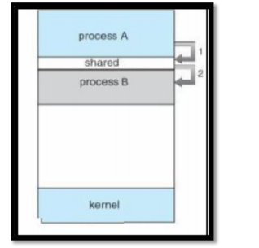

**• In this, all processes who want to communicate with other**

**processes can access a region of the memory residing in an**

**address space of a process creating a shared memory segment.**

**• All the processes using the shared memory segment should**

**attach to the address space of the shared memory. All the**

**processes can exchange information by reading and/or writing**

**data in shared memory segment.**

**• The form of data and location are determined by these processes**

**who want to communicate with each other.**

**• These processes are not under the control of the operating**

**system.**

**• The processes are also responsible for ensuring that they are not**

**writing to the same location simultaneously.**

**• After establishing shared memory segment, all accesses to the**

**shared memory segment are treated as routine memory access**

**and without assistance of kernel.**